**Add a new country**   
 **Java Files**

**Country.java**

package com.example.demo.entity;

import jakarta.persistence.Entity;

import jakarta.persistence.Id;

@Entity

public class Country {

@Id

private String code;

private String name;

public String getCode() {

return code;

}

public void setCode(String code) {

this.code = code;

}

public String getName() {

return name;

}

public void setName(String name) {

this.name = name;

}

@Override

public String toString() {

return "Country [code=" + code + ", name=" + name + "]";

}

}

## CountryRepository.java

package com.example.demo.repository;

import org.springframework.data.jpa.repository.JpaRepository;

import com.example.demo.entity.Country;

public interface CountryRepository extends JpaRepository<Country, String> {

}

## CountryService.java

package com.example.demo.service;

import org.springframework.beans.factory.annotation.Autowired;

import org.springframework.stereotype.Service;

import org.springframework.transaction.annotation.Transactional;

import com.example.demo.entity.Country;

import com.example.demo.repository.CountryRepository;

@Service

@Transactional

public class CountryService {

@Autowired

private CountryRepository countryRepository;

public Country findCountryByCode(String code) {

return countryRepository.findById(code).orElse(null);

}

public void addCountry(Country country) {

countryRepository.save(country);

}

}

## CountryController.java

package com.example.demo.controller;

import com.example.demo.entity.Country;

import com.example.demo.service.CountryService;

import org.springframework.beans.factory.annotation.Autowired;

import org.springframework.web.bind.annotation.*;

@RestController

@RequestMapping("/countries")

public class CountryController {

@Autowired

private CountryService countryService;

@PostMapping

public void addCountry(@RequestBody Country country) {

countryService.addCountry(country);

}

@GetMapping("/{code}")

public Country getCountry(@PathVariable String code) {

return countryService.findCountryByCode(code);

}

}

## DemoApplication.java

package com.example.demo;

import com.example.demo.entity.Country;

import com.example.demo.service.CountryService;

import org.slf4j.Logger;

import org.slf4j.LoggerFactory;

import org.springframework.beans.factory.annotation.Autowired;

import org.springframework.boot.CommandLineRunner;

import org.springframework.boot.SpringApplication;

import org.springframework.boot.autoconfigure.SpringBootApplication;

@SpringBootApplication

public class DemoApplication implements CommandLineRunner {

private static final Logger LOGGER = LoggerFactory.getLogger(DemoApplication.class);

@Autowired

private CountryService countryService;

public static void main(String[] args) {

SpringApplication.run(DemoApplication.class, args);

}

@Override

public void run(String... args) throws Exception {

testAddCountry();

}

private void testAddCountry() {

Country country = new Country();

country.setCode("JP");

country.setName("Japan");

countryService.addCountry(country);

Country added = countryService.findCountryByCode("JP");

LOGGER.info("Added country -> {}", added);

}

}

# Configuration Files

## application.properties

spring.datasource.url=jdbc:mysql://localhost:3306/countryadd

spring.datasource.username=root

spring.datasource.password=root

Server.port=8081

spring.jpa.hibernate.ddl-auto=update

spring.jpa.show-sql=true

spring.datasource.driver-class-name=com.mysql.cj.jdbc.Driver

## pom.xml

<project xmlns="http://maven.apache.org/POM/4.0.0" xmlns:xsi="http://www.w3.org/2001/XMLSchema-instance"

xsi:schemaLocation="http://maven.apache.org/POM/4.0.0 http://maven.apache.org/xsd/maven-4.0.0.xsd">

<modelVersion>4.0.0</modelVersion>

<groupId>com.example</groupId>

<artifactId>demo</artifactId>

<version>0.0.1-SNAPSHOT</version>

<parent>

<groupId>org.springframework.boot</groupId>

<artifactId>spring-boot-starter-parent</artifactId>

<version>3.2.5</version>

</parent>

<dependencies>

<dependency>

<groupId>org.springframework.boot</groupId>

<artifactId>spring-boot-starter-web</artifactId>

</dependency>

<dependency>

<groupId>org.springframework.boot</groupId>

<artifactId>spring-boot-starter-data-jpa</artifactId>

</dependency>

<dependency>

<groupId>com.mysql</groupId>

<artifactId>mysql-connector-j</artifactId>

<scope>runtime</scope>

</dependency>

</dependencies>

<build>

<plugins>

<plugin>

<groupId>org.springframework.boot</groupId>

<artifactId>spring-boot-maven-plugin</artifactId>

</plugin>

</plugins>

</build>

</project>

**Output:**

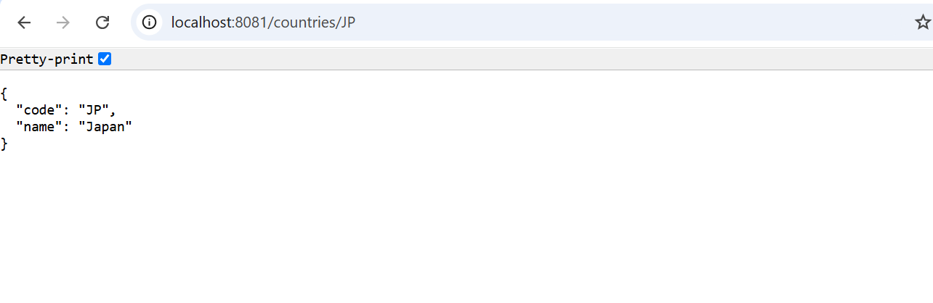

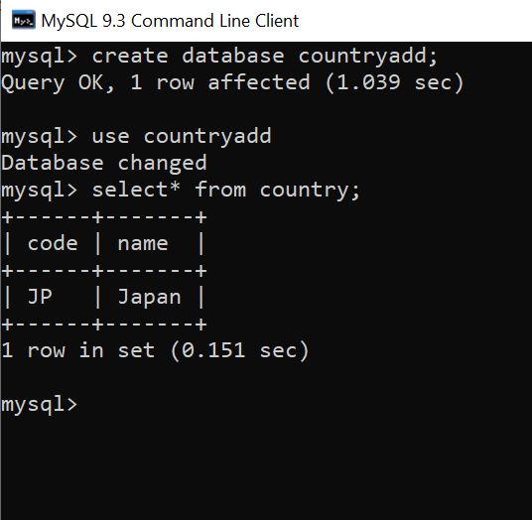

s